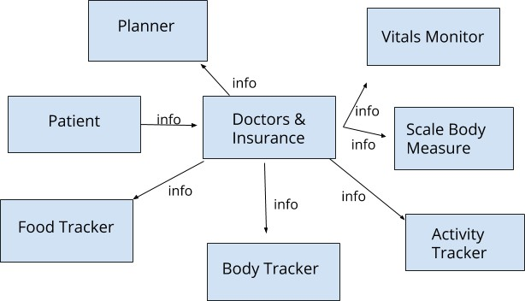

Project Design Phase-II

Data Flow Diagram & User Stories

|  |  |
| --- | --- |
| Date | 13 October 2022 |
| Team ID | PNT2022TMID41312 |
| Project Name | Project – AI-Powered Nutrition Analyzer for Fitness Enthusiasts |
| Maximum Marks | 4 Marks |

# Data Flow Diagrams:

A Data Flow Diagram (DFD) is a traditional visual representation of the information flows within a system. A neat and clear DFD can depict the right amount of the system requirement graphically. It shows how data enters and leaves the system, what changes the information, and where data is stored.

DFD Level 0 (Nutrition analyser)

# Example: Flow diagram

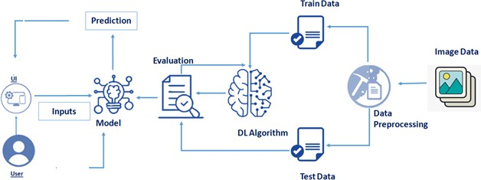

**User Stories**

Use the below template to list all the user stories for the product.

|  |  |  |  |  |  |  |
| --- | --- | --- | --- | --- | --- | --- |
| **User Type** | **Functional Requirement (Epic)** | **User Story Number** | **User Story / Task** | **Acceptance criteria** | **Priority** | **Release** |
| Customer (Mobile user) | Registration | USN-1 | As a user, I can register for the application by  entering my email, password, and confirming my password. | I can access my account / dashboard | High | Sprint-1 |
|  |  | USN-2 | As a user, I will receive confirmation email once I have registered for the application | I can receive confirmation email & click confirm | High | Sprint-1 |
|  |  | USN-3 | As a user, I can register for the application through Facebook | I can register & access the dashboard with Facebook Login | Low | Sprint-2 |
|  |  | USN-4 | As a user, I can register for the application through Gmail | I can register and access the application through Gmail | Medium | Sprint-1 |
|  | Login | USN-5 | As a user, I can log into the application by entering email & password | I can access the application by entering  email and password | High | Sprint-1 |
|  | Dashboard | USN-6 | User will find a detailed information regarding the application through which user will have a better idea of how to use it | Now I have a good idea of how to use it and it provides ease of access | Medium | Sprint-1 |
| Customer (Web user) | Application | USN-7 | As a logged in user, I want be able to add meals and have a over all view of what I am eating | I want to add the overall view of what I am eating | High | Sprint -1 |
|  |  | USN-8 | As a user, I want a link to a weekly summary | I want a link to access the weekly summary | Medium | Sprint -1 |
|  |  | USN-9 | As a user, when I click on the nutrition profile I want it easily readable with most relevant information at the top. | I want my profile to be ease readable and user friendly | High | Sprint -1 |
|  |  | USN-10 | As a user, when I view my weekly totals I want averages and other pertinant information displayed neatly | I want my pertinent information to be displayed neately | Medium | Sprint-2 |